**Question 7**

**In Cisco Packet Tracer, create a small network with multiple devices (e.g., 2 PCs and a router). Use private IP addresses (e.g., 192.168.1.x) on the PCs and configure the router to perform NAT to allow the PCs to access the internet.**

**Task: Test the NAT configuration by pinging an external IP address from the PCs and capture the traffic using Wireshark.**

**What is the source IP address before and after NAT?**

**Approach**

**NAT (Network Address Translation)** is a process that allows multiple devices in a **private network** to access the **internet** using a **single public IP address**. It translates **private IPs** (e.g., 192.168.x.x) into a **public IP** when sending data outside the network and reverses the process for incoming traffic.

**Types of NAT:**

1. **Static NAT** – One-to-one mapping between private and public IPs.
2. **Dynamic NAT** – Assigns a public IP from a pool dynamically.
3. **PAT (Port Address Translation)** – Many private IPs share **one** public IP using different ports (Most common).

We are demonstrating the NAT using cisco packet tracer. We are having 2 pc’s which is connected to a switch that is connected to the router. On the other network we have a server and switch both are connected. The switch is connected to router.

We are you going to make our private network to communicate with the public network which has web server

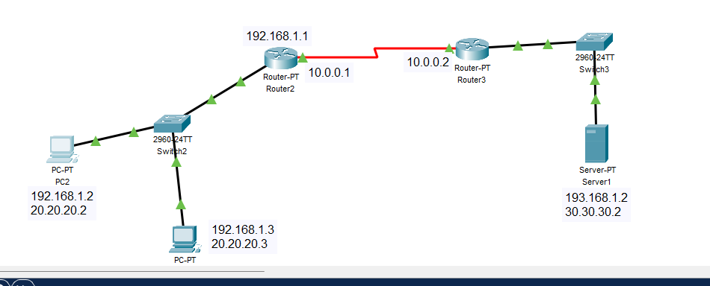

After connecting two router, Let’s start to configure

* Set the public address for each device in both network. Use the below command
  + Ip nat inside source static [your IP] [Public IP]





Once done, now set the ip nat to inside because all private devices are in one network.

And set one ip nat to outside network which is connected to web server





Now we are going to add route to our public ip of webserver.

Ip route [Public IP] [subnet mask] [next_hop ip]

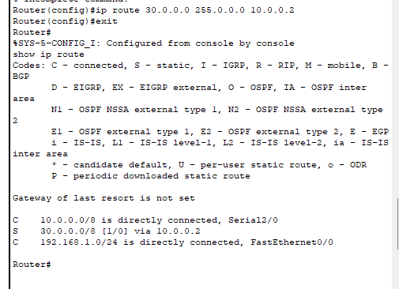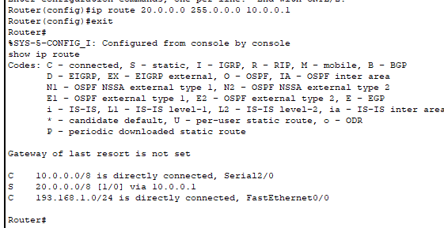

Now try to ping the neighbour PC with it’s private IP

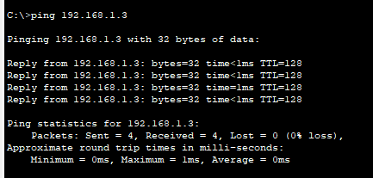

Now try to ping the web server with it’s private IP

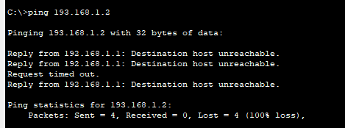

As you can see the destination host is not reachable.

Now if you try to ping it with public ip, you can successfully able to ping it.

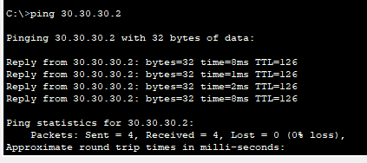

Source ip before NAT is the private ip of the host, but the source ip after nat is the public ip of the host

